Executive summary - This project presents an end-to-end Privacy, Data Protection, and AI Governance assessment of FitMind AI, a fictional AI-powered fitness and nutrition application.
The assessment focuses on how personal data is collected, processed, stored, shared and deleted within the application. It also examines privacy risks associated with the use of an external AI service for personalised recommendations.
The project includes a data inventory, data flow assessment, privacy risk assessment, data retention and deletion framework, privacy controls, AI governance measures and controls.
The objective of this project is to demonstrate the practical application of data privacy and AI governance principles in an AI-enabled digital service.

Business Overview –FitMind AI is a fictional AI-powered fitness and nutrition application designed to provide users with personalised workout and nutrition recommendations.
Business Activities:
- User Registration & Account Creation
- Fitness Profile Creation
- Personalised Workout & Nutrition Recommendations
- AI Fitness Assistant
- Payment & Subscription
- Customer Support & Communication
FitMind AI processes user information to create accounts, understand fitness profiles, provide personalised recommendations, operate its AI fitness assistant, process subscriptions and provide customer support .
Data Inventory - A data inventory was created to identify the personal and authentication-related information processed by FitMind AI. The inventory records the data element, category, business activity, source, purpose, processing system, access, third-party sharing, retention period and risk level.
Data element category purpose risk
Full name personal data Account identification medium
email address contact data registration & communication medium
Password (Hashed) authentication data account security high
Age,height,weight Demographic Data personalization medium

Data Flow –
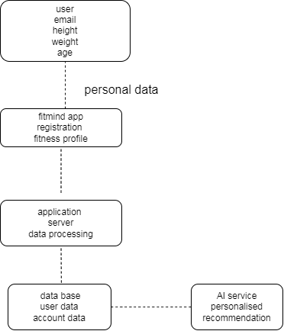
User data is collected through the FitMind AI application and transferred to the application server for authentication and processing. Relevant account and fitness profile information is stored in the database. Only minimum necessary fitness information is shared with the AI service to generate personalised recommendations. The recommendation is returned through the application server to the user.
Privacy Risk Assessment - A simple 3×3 Impact × Likelihood risk-scoring methodology was used for this portfolio assessment.
Score |  | Risk Level
1–2 |  | Low
3–4 |  | Medium
6–9 |  | High
ID | Risk |  |  | Score | Level
R-01 | Unauthorised access to user personal data |  |  | 6 | High
R-02 | Excessive personal data sharing with AI service |  |  | 6 | High
R-03 | Personal data retained longer than necessary |  |  | 4 | Medium
R-04 | Inaccurate/inappropriate AI recommendations |  |  | 6 | High
Controls were identified for each risk to reduce the likelihood or impact of the identified risk. Residual risk was also considered after applying the proposed controls.
Data Retention & Deletion - A data retention and deletion schedule was developed to establish how long different categories of user data should be retained and when deletion should be triggered.
DATA | RETE NTION | Deletion Trigger
Full Name | Until account deletion | Account deletion
Email | Until account deletion | Account deletion
Hashed Password | Until account deletion | Account deletion/replacement
Age, height, weight until account deletion account deletion
Privacy Controls –
• Role-Based Access Control
• Strong Authentication
• Encryption
• Data Minimisation
• Purpose Limitation
• Retention Schedule
• Deletion Process
• Human Oversight
• AI Output Testing
Privacy controls were designed to address the identified risks and support principles such as data minimisation, purpose limitation, access control, security and responsible AI use.
AI Governance –
AREA CONTROL
Purpose | AI generates personalised fitness and nutrition recommendations
Data Minimisation | Only necessary data is provided to AI
Transparency | Users are informed when AI is used
Human Oversight | High-risk outputs can be reviewed
Accuracy | AI outputs are tested and monitored
Safety | Rules restrict potentially harmful recommendations
Accountability | Responsibility for AI monitoring is assigned
Monitoring | AI performance is periodically reviewed

Conclusion
The FitMind AI assessment demonstrates how privacy, cybersecurity and AI governance can be considered together when designing an AI-enabled application.
The project identified the types of personal data processed by the application, mapped important data flows, assessed privacy risks, established retention and deletion considerations and developed privacy and cybersecurity controls. The assessment also highlights the importance of data minimisation, transparency, human oversight, AI safety and continuous monitoring when AI services are used to process personal information.
Disclaimer - This is a fictional educational portfolio project created for learning and demonstration purposes. It does not represent a real organisation or real user/customer data. The retention periods, risk scores and controls are illustrative assumptions and should not be treated as legal advice or universal regulatory requirements.

